Unit testing

1. Create new Win32 project as DLL library.

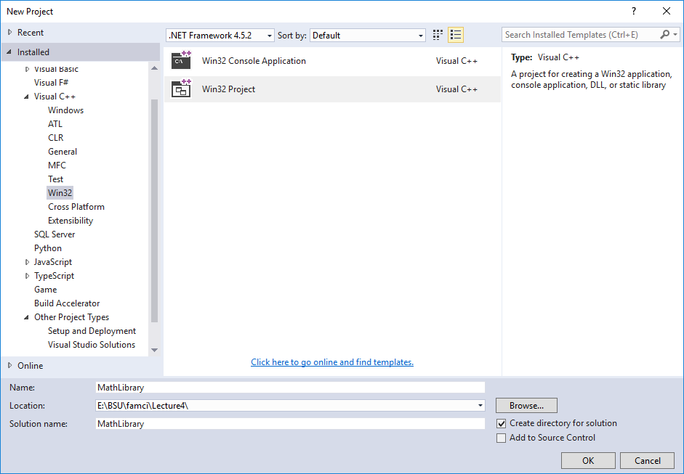

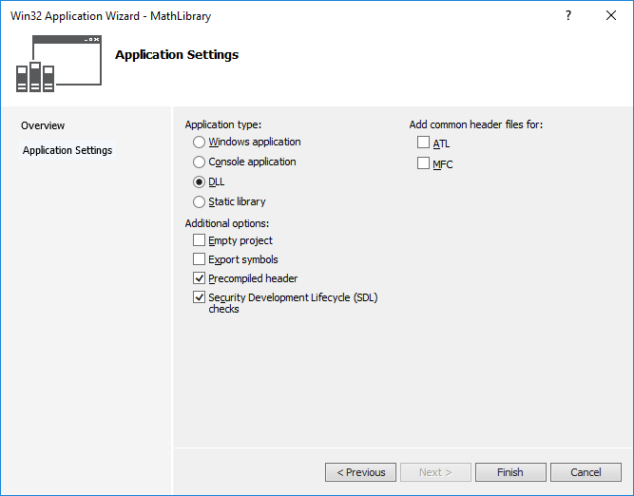

1. Add header file MathLibrary.h and MathLibrary.cpp

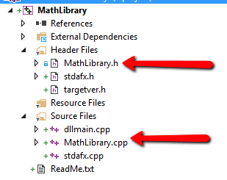

1. Create Console Application project that uses our MathLibrary.

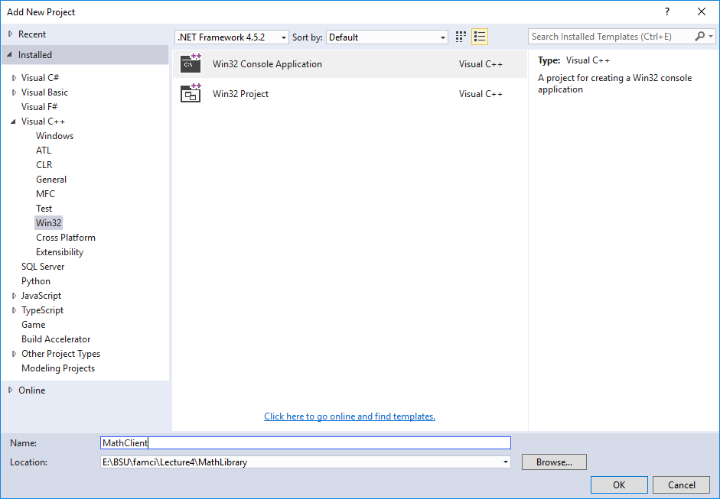

1. Add reference to MathLibrary DLL into ConsoleApplication project.(OR simply copy it, but in this case you need to update MathLibrary.h each time when you change it in DLL project).

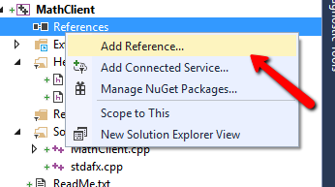

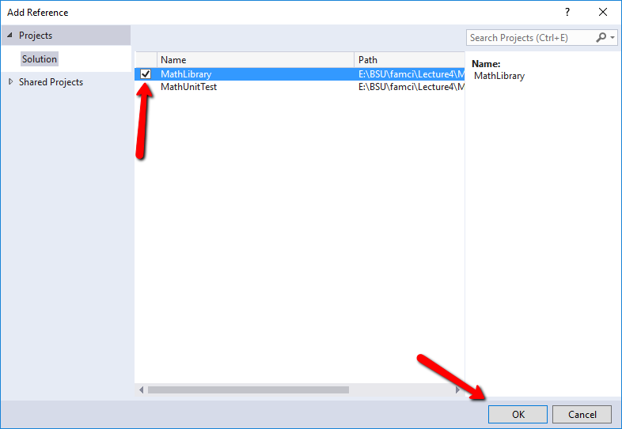

1. In MathClient.cpp use the relative path to MathLibrary.h file:

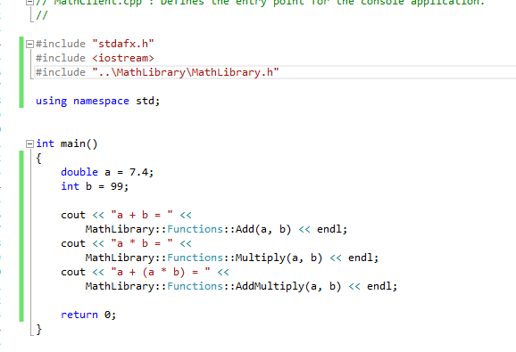

1. Create Unit Test project

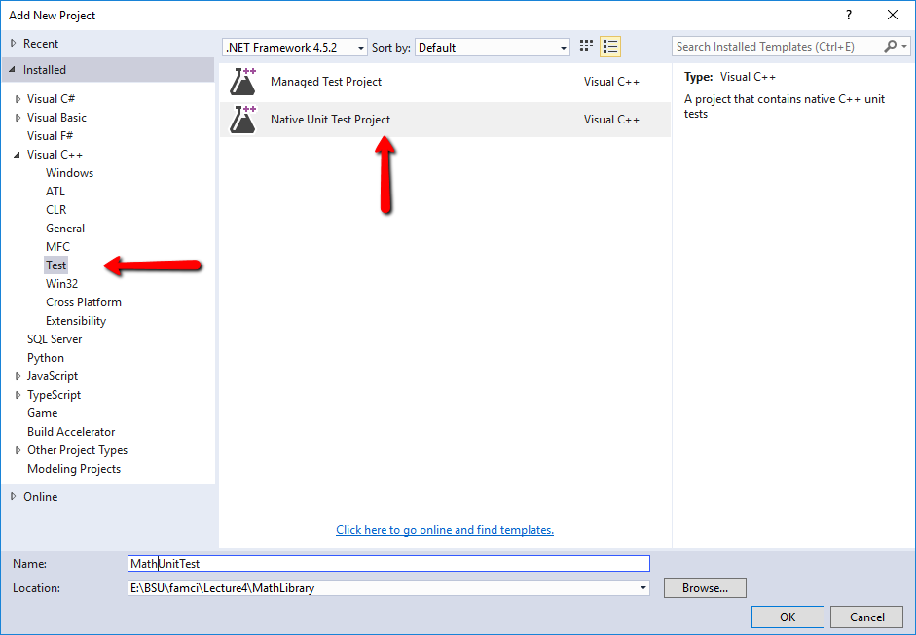

1. To show Test Explorer window, open it via top level menu Test ->Windows ->Test Explorer.

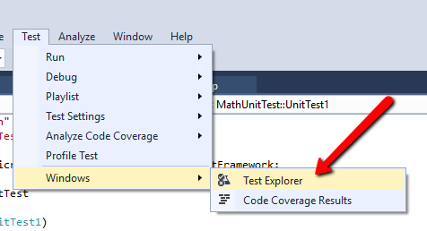

1. To check that test works, add the following line of code and run test in Test Explorer:

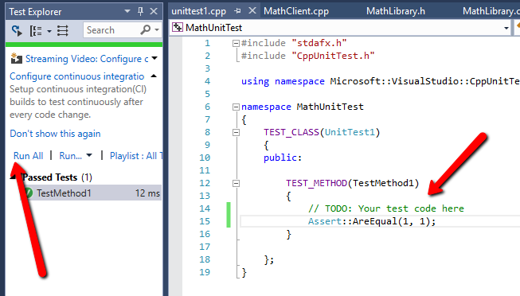

1. Add reference to the MathLibrary DLL as it was already done for MathCLient. Include MathLibrary.h using relative path and implement the test for method Add:

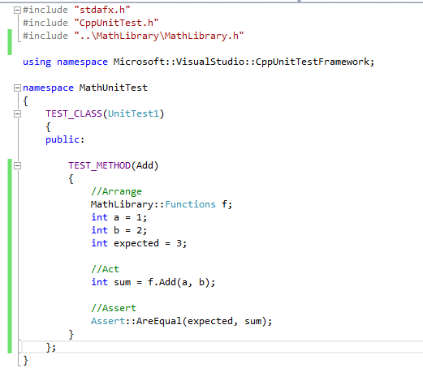

MathLibrary.h

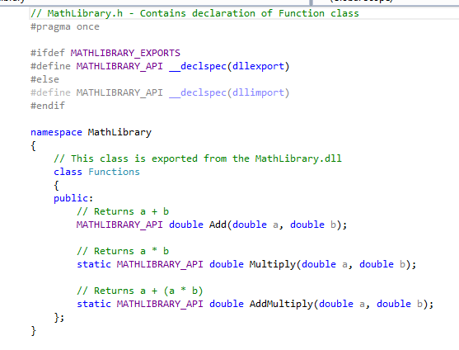

MathLibrary.cpp

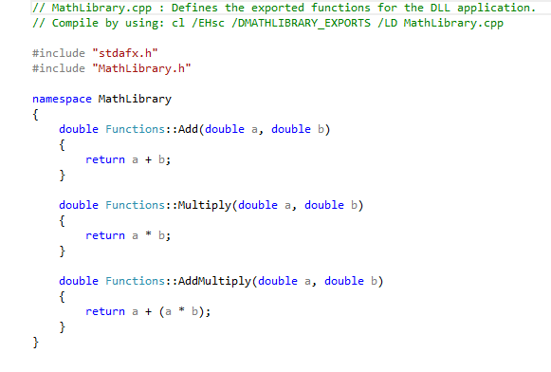

MathClient.cpp

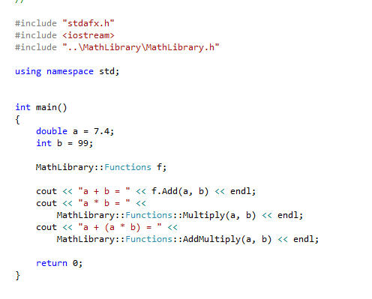

Unittest1.cpp

